Mali

## Population Data

The data set shows the political stability estimate of the country each year.

## # A tibble: 23 x 5  
## country iso3c date population popCategory5  
## <chr> <chr> <dbl> <dbl> <chr>   
## 1 Mali MLI 1996 9837571 small   
## 2 Mali MLI 1997 10094368 small   
## 3 Mali MLI 1998 10360561 small   
## 4 Mali MLI 1999 10642936 small   
## 5 Mali MLI 2000 10946445 small   
## 6 Mali MLI 2001 11271600 small   
## 7 Mali MLI 2002 11616887 small   
## 8 Mali MLI 2003 11982695 small   
## 9 Mali MLI 2004 12369070 small   
## 10 Mali MLI 2005 12775516 small   
## 11 Mali MLI 2006 13203378 small   
## 12 Mali MLI 2007 13651464 small   
## 13 Mali MLI 2008 14113577 small   
## 14 Mali MLI 2009 14581429 small   
## 15 Mali MLI 2010 15049353 small   
## 16 Mali MLI 2011 15514591 small   
## 17 Mali MLI 2012 15979499 small   
## 18 Mali MLI 2013 16449864 small   
## 19 Mali MLI 2014 16934220 small   
## 20 Mali MLI 2015 17438778 small   
## 21 Mali MLI 2016 17965429 small   
## 22 Mali MLI 2017 18512394 small   
## 23 Mali MLI 2018 19077690 small

# Population growth data

## # A tibble: 23 x 5  
## country iso3c date popGrowth popGrowthCat5   
## <chr> <chr> <dbl> <dbl> <chr>   
## 1 Mali MLI 1996 2.59 high growth rate  
## 2 Mali MLI 1997 2.58 high growth rate  
## 3 Mali MLI 1998 2.60 high growth rate  
## 4 Mali MLI 1999 2.69 high growth rate  
## 5 Mali MLI 2000 2.81 high growth rate  
## 6 Mali MLI 2001 2.93 high growth rate  
## 7 Mali MLI 2002 3.02 high growth rate  
## 8 Mali MLI 2003 3.10 high growth rate  
## 9 Mali MLI 2004 3.17 high growth rate  
## 10 Mali MLI 2005 3.23 high growth rate  
## 11 Mali MLI 2006 3.29 high growth rate  
## 12 Mali MLI 2007 3.34 high growth rate  
## 13 Mali MLI 2008 3.33 high growth rate  
## 14 Mali MLI 2009 3.26 high growth rate  
## 15 Mali MLI 2010 3.16 high growth rate  
## 16 Mali MLI 2011 3.04 high growth rate  
## 17 Mali MLI 2012 2.95 high growth rate  
## 18 Mali MLI 2013 2.90 high growth rate  
## 19 Mali MLI 2014 2.90 high growth rate  
## 20 Mali MLI 2015 2.94 high growth rate  
## 21 Mali MLI 2016 2.98 high growth rate  
## 22 Mali MLI 2017 3.00 high growth rate  
## 23 Mali MLI 2018 3.01 high growth rate

## Population trend

The plot shows the population trend of the country.

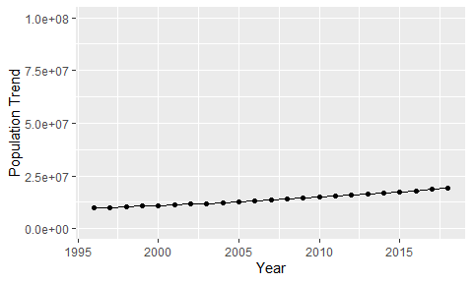

Political Stability Trend

# Population growth trend

The plot shows the population growth rate trend of the country.

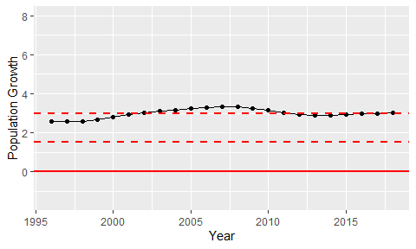

Population Growth Trend